 | INDEX
Title
Declaration of the Student |  | i
Certificate of the Guide |  | ii
Abstract |  | iii
Acknowledgement |  | iv
List of Figures |  | v
1.INTRODUCTION |  | 1
1.1 | Overview | 1
1.2 | Purpose | 1
2. LITERATURE SURVEY |  | 1
2.1 | Existing Problem | 1
2.2 | Proposed Solution | 1
3. THEORITICAL ANALYSIS |  | 1
3.1 | Block Diagram | 1
3.2 | Software and Hardware Designing | 2
4. EXPERIMENTAL INVESTIGATION |  | 2
5. FLOW CHART |  | 2
6. RESULT |  | 2
7. ADVANTAGES & DISADVANTAGES |  | 3
8. APPLICATIONS |  | 4
9. CONCLUSION |  | 4
10. FUTURE SCOPE |  | 4
11. APPENDIX |  | 4
A Bibliography |  | 4
B Source code |  | 4
PLANT DISEASE FERTILIZER RECCOMENDATION SYSTEM

A MINI PROJECT REPORT

Submitted by

T. Akanksha R. Ramya sree S. Priya sahithi
17RH1A05M4 17RH1A05K3 17RH1A05L1

Under the Esteemed Guidance of

Dr. C.V.P.R. PRASAD

Professor & Head

in partial fulfilment of the Academic Requirements for the Degree of

BACHELOR OF TECHNOLOGY

Computer Science and Engineering


MALLA REDDY ENGINEERING COLLEGE FOR WOMEN

(Autonomous Institution, UGC, Govt. of India)

Permanently Affiliated to JNTUH, Approved by AICTE, ISO 9001:2015 Certified Institution

Accredited by NBA &NAAC with ‘A’ Grade UGC, Govt. of India NIRF Indian Ranking–2018, Accepted by MHRD, Govt. of India

AAA+ Rated by Careers 360 Magazine, National Ranking-Top 100 Rank band by Outlook Maisammaguda, Dhulapally (Post Via Kompally), Secunderabad - 500100

January-2021

MALLA REDDY ENGINEERING COLLEGE FOR WOMEN

(Autonomous Institution –UGC, Govt. of India)


(Permanently Affiliated to JNTU, Hyderabad, Approved by AICTE - ISO 9001:2015 Certified)

Accredited by NBA & NAAC with ‘A’ Grade

NIRF India Ranking 2018, Accepted by MHRD, Govt. of India

Maisammaguda, Dhulapally (Post Via Kompally), Secunderabad – 500100

Department of Computer Science and Engineering

DECLARATION

We hereby declare that the Mini Project entitled “PLANT DISEASE FERTILIZER RECCOMENDATION SYSTEM” submitted to Malla Reddy Engineering College for Women affiliated to Jawaharlal Nehru Technological University, Hyderabad (JNTUH) for the award of the Degree of Bachelor of Technology in Computer Science and Engineering is a result of original research work done by us.

It is further declared that the Mini project report or any part thereof has not been previously submitted to any University or Institute for the award of Degree.

T. AKANKSHA (17RH1A05M4)

R. RAMYA SREE (17RH1A05K3)

S. PRIYA SAHITHI (17RH1A05L1)

i

MALLA REDDY ENGINEERING COLLEGE FOR WOMEN

(Autonomous Institution –UGC, Govt. of India)

(Permanently Affiliated to JNTU, Hyderabad, Approved by AICTE - ISO 9001:2015 Certified)

Accredited by NBA & NAAC with ‘A’ Grade

NIRF India Ranking 2018, Accepted by MHRD, Govt. of India

Maisammaguda, Dhulapally (Post Via Kompally), Secunderabad – 500100

Department of Computer Science and Engineering

CERTIFICATE

This is to certify that the Mini Project work entitled “PLANT DISEASE FERTILIZER RECCOMENDATION SYSTEM” is carried out by T. Akanksha (17RH1A05M4), R. Ramya sree (17RH1A05K3), S. Priya sahithi (17RH1A05L1) in partial fulfilment for the award of degree of BACHELOR OF TECHNOLOGY in Computer Science and Engineering, Jawaharlal Nehru Technological University, Hyderabad during the academic year 2020-2021.

Supervisor’s Signature Head of the Department

Mr. Ramana Dr. C.V.P.R. PRASAD
Assistant Professor Professor

ii

ABSTRACT

Agriculture is the most important sector in today’s life. Most of the plants are affected by a wide variety of bacterial and fungal diseases. Diseases on plants placed a major constraint on the production and major threat to food security. Hence, early and accurate identification of plant diseases are essential to ensure high quantity and best quality. In recent years, the number of diseases on plants and degree of harm caused has increased due to the variation in pathogen varieties, changes in cultivation methods and inadequate plant protection techniques. An automated system is introduced to identify different diseases on plants by checking the symptoms shown on the leaves of the plant. Deep learning techniques are used to identify the diseases and suggest the precautions that can be taken for those diseases.

iii

ACKNOWLEDGEMENT

We feel ourselves honoured and privileged to place our warm salutation to our college Malla Reddy Engineering College for Women and Department of Computer Science and Engineering which gave us the opportunity to have expertise in engineering and profound technical knowledge.

We would like to deeply thank our Honourable Minister of Telangana State Sri. Ch. MALLAREDDY Garu, Founder Chairman MRGI, the largest cluster of institutions in the state of Telangana for providing us with all the resources in the college to make our project success.

We wish to convey gratitude to our Principal Dr. Y. MADHAVEE LATHA, for providing us with the environment and means to enrich our skills and motivating us in our endeavour and helping us to realize our full potential.

We would like to thank Prof. A. RADHA RANI, Director of Computer Science and Engineering & Information Technology for encouraging us to take up a project on this subject and motivating us towards the project work.

We express our sincere gratitude to Dr. C.V.P.R. PRASAD, Head of the Department of Computer Science and Engineering for inspiring us to take up a project on this subject and successfully guiding us towards its completion.

We would also like to thank our Project Co-ordinator Mr. Ramana, Assistant Professor for his kind encouragement and overall guidance in viewing this program a good asset with profound gratitude and encouragement towards the completion of our project work.

With Regards and Gratitude

T. AKANKSHA (17RH1A05M4)

R. RAMYA SREE (17RH1A05K3)

S. PRIYA SAHITHI (17RH1A05L1)

iv

LIST OF FIGURES

S No. | Figure Name
1 | Architecture Diagram
2 | Outputs


v
1. INTRODUCTION

  - Overview
The project Plant Disease Fertilizer Recommendation System is a web application developed by Deep Learning in which the user can upload the images of plant leaves which are affected by diseases and will get to know the problem and predicted solution to recover the plant diseases.

1.2 Purpose
Farmers or Gardeners are often worried about the plant diseases and the effect of diseases on plants. The aim of the Plant Disease Fertilizer Recommendation System is to find solution for the plant disease and for suggesting ideas to avoid such type of diseases by using recommended fertilizers.

2 LITERATURE SURVEY

2.1 Existing Problem
Farmers spend so much money on disease management, often without adequate technical support, resulting in poor disease control, pollution and harmful results. In addition, plant disease can devastate natural ecosystems, compounding environmental problems caused by habitat loss and poor land management. A symptom of plant disease is a visible effect of disease on the plant. Symptoms may include a detectable change in colour, shape or function of the plant as it responds to the pathogen. Leaf wilting is a typical symptom.

2.2 Proposed Solution
An automated system is introduced to identify different diseases on plants by checking the symptoms shown on the leaves of the plant. Deep learning techniques are used to identify the diseases and suggest the precautions that can be taken for those diseases.

3. THEORITICAL ANALYSIS

3.1 Block Diagram
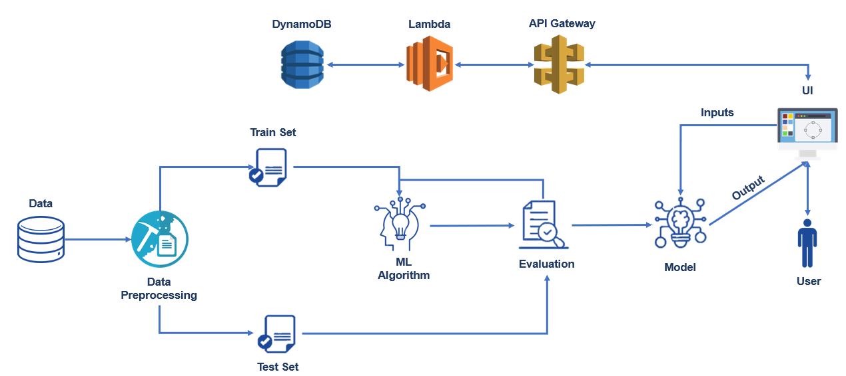

In the above block diagram, the dataset (images of different kind of fruits and vegetables plant leaves which are affected from different kind of diseases) is classified into train and test sets. Algorithms are performed on train set and then the train and test sets are evaluated. At the end a deep

1

learning model is built. User gives the input (plant disease image) and the model provides predicted
output (the disease from which the plant is affected and fertilizer to recover it) to the user.
DynamoDB on AWS cloud is used to store the user’s data, Lambda and API Gateway are used to retrieve user’s data.

3.2 Software and Hardware Designing

Software Used
- Python (version 3.6x)
- Anaconda 3
- Jupyter Notebook & Spyder
- Windows 7 or higher
- Python Flask

Hardware Required
- Processor – Dual Core or higher
- Hard Disk – 50 GB
- Memory – 1GB RAM

4. EXPERIMENTAL INVESTIGATION
According to the International Research Journal of Engineering and Technology (IRJET), the proposal introduced in 2019 which deals with IOT based system using hardware and various image processing tools. Detection and recognition of plant diseases using Deep learning is efficient providing symptoms of identifying diseases at its earliest. This project is a Deep learning model with highest accuracy rate and the least error.

5. FLOW CHART

2
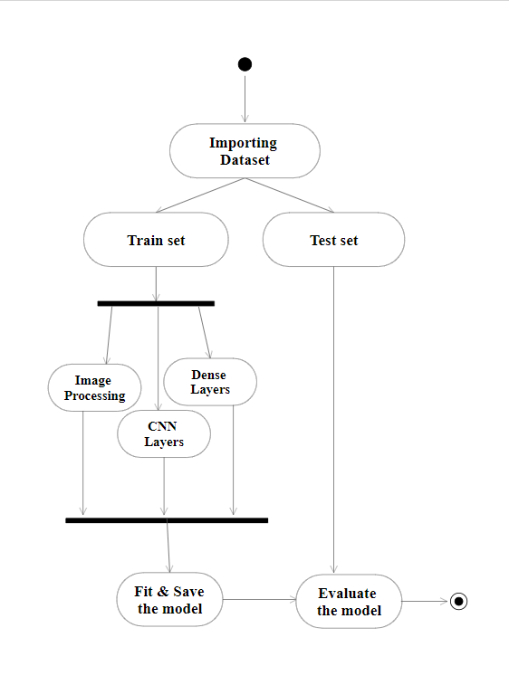

6. RESULT
The final model helps the users to find the disease of the plant and recommend the fertilizer for affected leaves based on severity level. Fertilizers may be organic or inorganic and it suggests the fertilizers and measurements of fertilizers based on the disease severity level.

7. ADVANTAGES & DISADVANTAGES
Advantages:
- It helps farmers or gardeners to know the disease from which the plant is affected from.
- It provides a recommended fertilizer to the users to recover plants from diseases.

3
- It is more flexible for the users to browse the images of plant disease leaves.
- It increases the crop yielding.
- The chance of occurrence of error is very less.
- It is fast efficient and reliable.
- Avoids data redundancy and inconsistency.
- It is a system user- friendly.
- Easy accessibility of data.

Disadvantages:

- It requires internet connection.
- Appropriate plant disease leaf images should be uploaded for anticipated output.

8. APPLICATIONS
- It is used by gardeners and farmers to predict the plant diseases.
- It is used for both fruit and vegetable plant diseases prediction and for its recovery.

9. CONCLUSION
On the basis of the fruit and vegetable plant disease dataset, the proposed model provides the users disease from which the plant is affected from and recommends fertilizer to recuperate the affected area. We have loaded the dataset into the model and checked its outcome. We have achieved 91% of accurate result from obtained outcome. By this we conclude that the project Plant Disease Fertilizer Recommendation System is accurate.

10. FUTURE SCOPE
This future research is implementing the proposed algorithm with the existing public datasets. Also, various segmentation algorithms can be implemented to improve accuracy. The proposed algorithm can be modified further to identify the disease that affects the various plant organs such as stems and fruits.

11. APPENDIX
A Bibliography
[1] https://www.google.com/url?sa=t&source=web&rct=j&url=https://www.mdpi.com/journal/agriculture/special_issues/plant_disease%23:~:text%3DFarmers%2520spend%2520billions%2520of%2520dollars,loss%2520and%2520poor%2520land%2520management.&ved=2ahUKEwiky9yP5OvtAhU9lEsFHYEfAkoQFjABegQIBhAE&usg=AOvVaw1qCIuBVfz2OvyZMF_PFlhc&cshid=1608990355977

[2] https://www.semanticscholar.org/paper/Fertilizers-Recommendation-System-For-Disease-In-Neela-Nithya/495379d3ef2b461fabd2de8d0605c164cb1e396f

B Source Code

app.py

import requests
from keras.preprocessing import image
from tensorflow.keras.models import load_model
import numpy as np
import pandas as pd

4
import tensorflow as tf

from flask import Flask, request, render_template, redirect, url_for
import os
from werkzeug.utils import secure_filename
from tensorflow.python.keras.backend import set_session
app = Flask(__name__)
global sess
sess = tf.Session()
global graph
graph=tf.compat.v1.get_default_graph()
set_session(sess)
#load both the vegetable and fruit models
model = load_model("vegetable.h5")
model1=load_model("fruit.h5")
#integrate the api to retrieve the data based on email
def check(email):
url = "https://xtcx2dz8nf.execute-api.us-east-1.amazonaws.com/plant-disease/login?email="+email
status = requests.request("GET",url)
print(status.json())
return status.json()
#home page
@app.route('/')
def home():
return render_template('home.html')
#registration page
@app.route('/register')
def register():
return render_template('register.html')
@app.route('/afterreg', methods=['POST'])
def afterreg():
x = [x for x in request.form.values()]
print(x)
params = "name="+x[0]+"&email="+x[1]+"&phone="+x[2]+"&password="+x[3]
#check if the user is already registered or not
if('errorType' in check(x[1])):
url = " https://xtcx2dz8nf.execute-api.us-east-1.amazonaws.com/plant-disease?"+params
response = requests.get(url)

5
return render_template('register.html', pred="Registration Successful, please login using your details")
else:
return render_template('register.html', pred="You are already a member, please login using your details")
#login page
@app.route('/login')
def login():
return render_template('login.html')
@app.route('/afterlogin',methods=['POST'])
def afterlogin():
user = request.form['uname']
passw = request.form['psw']
print(user,passw)
data = check(user)
#check with the valid credentials
if('errorType' in data):
return render_template('login.html', pred="The username is not found, recheck the spelling or please register.")
else:
if(passw==data['password']):
return redirect(url_for('prediction'))
else:
return render_template('login.html', pred="Login unsuccessful. You have entered the wrong password.")
#prediction page
@app.route('/prediction')
def prediction():
return render_template('predict.html')
@app.route('/predict',methods=['POST'])
def predict():
if request.method == 'POST':
# Get the file from post request
f = request.files['image']
# Save the file to ./uploads
basepath = os.path.dirname(__file__)
file_path = os.path.join(
basepath, 'uploads', secure_filename(f.filename))
f.save(file_path)
img = image.load_img(file_path, target_size=(128, 128))
x = image.img_to_array(img)
x = np.expand_dims(x, axis=0)

6
plant=request.form['plant']
print(plant)
if(plant=="vegetable"):
with graph.as_default():
set_session(sess)
preds = model.predict_classes(x)
print(preds)
df=pd.read_excel('precautions - veg.xlsx')
print(df.iloc[preds[0]]['caution'])
else:
with graph.as_default():
set_session(sess)
preds = model1.predict_classes(x)
df=pd.read_excel('precautions - fruits.xlsx')
print(df.iloc[preds[0]]['caution'])
return df.iloc[preds[0]]['caution']
@app.route('/logout')
def logout():
return render_template('logout.html')
if __name__ == "__main__":
app.run(debug=True)

Fruit-Training.ipynb

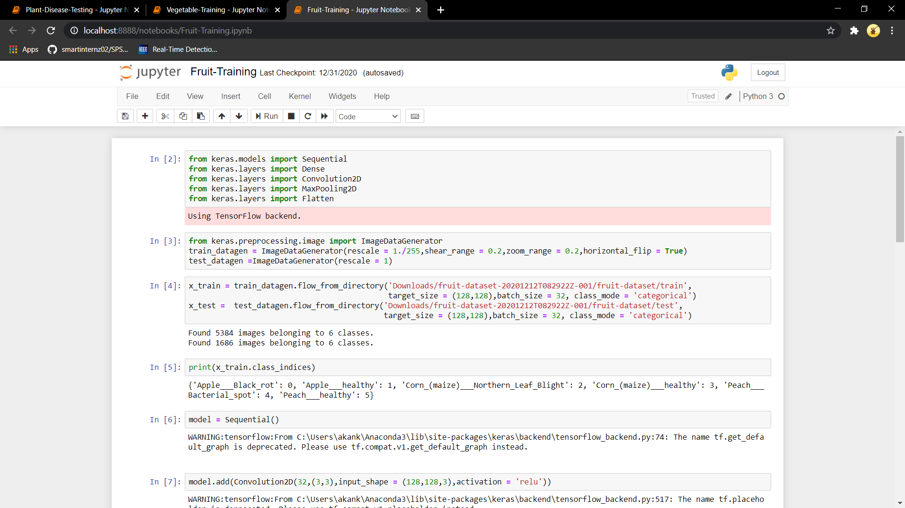

7
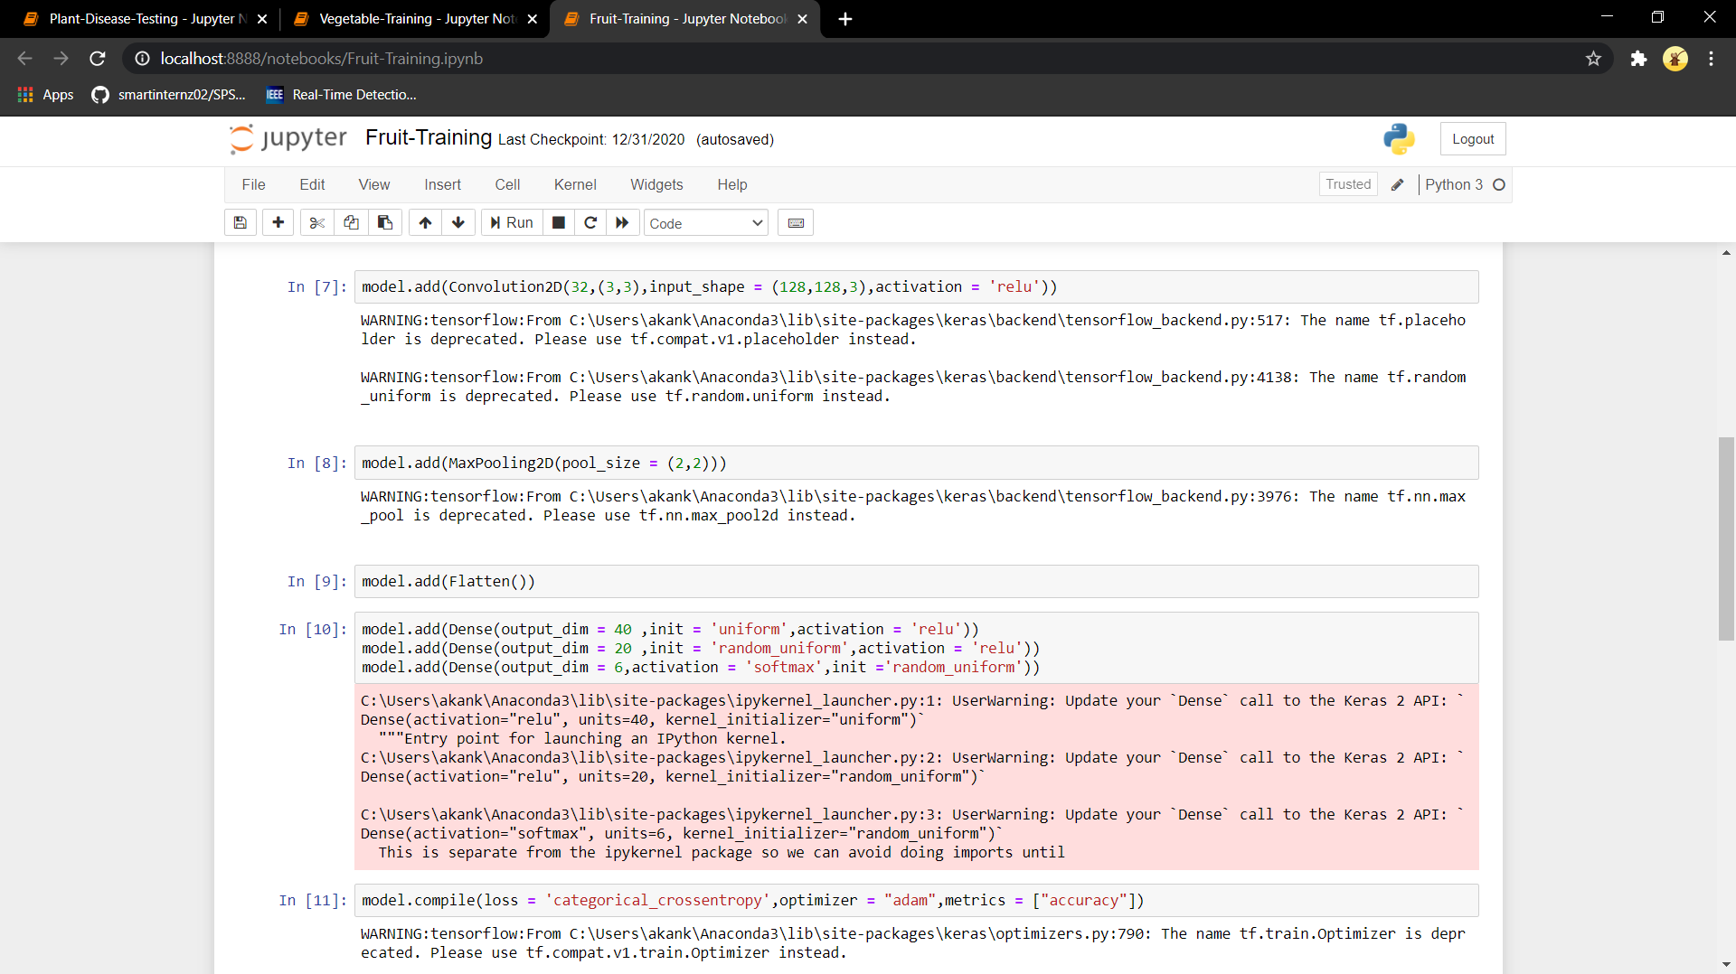

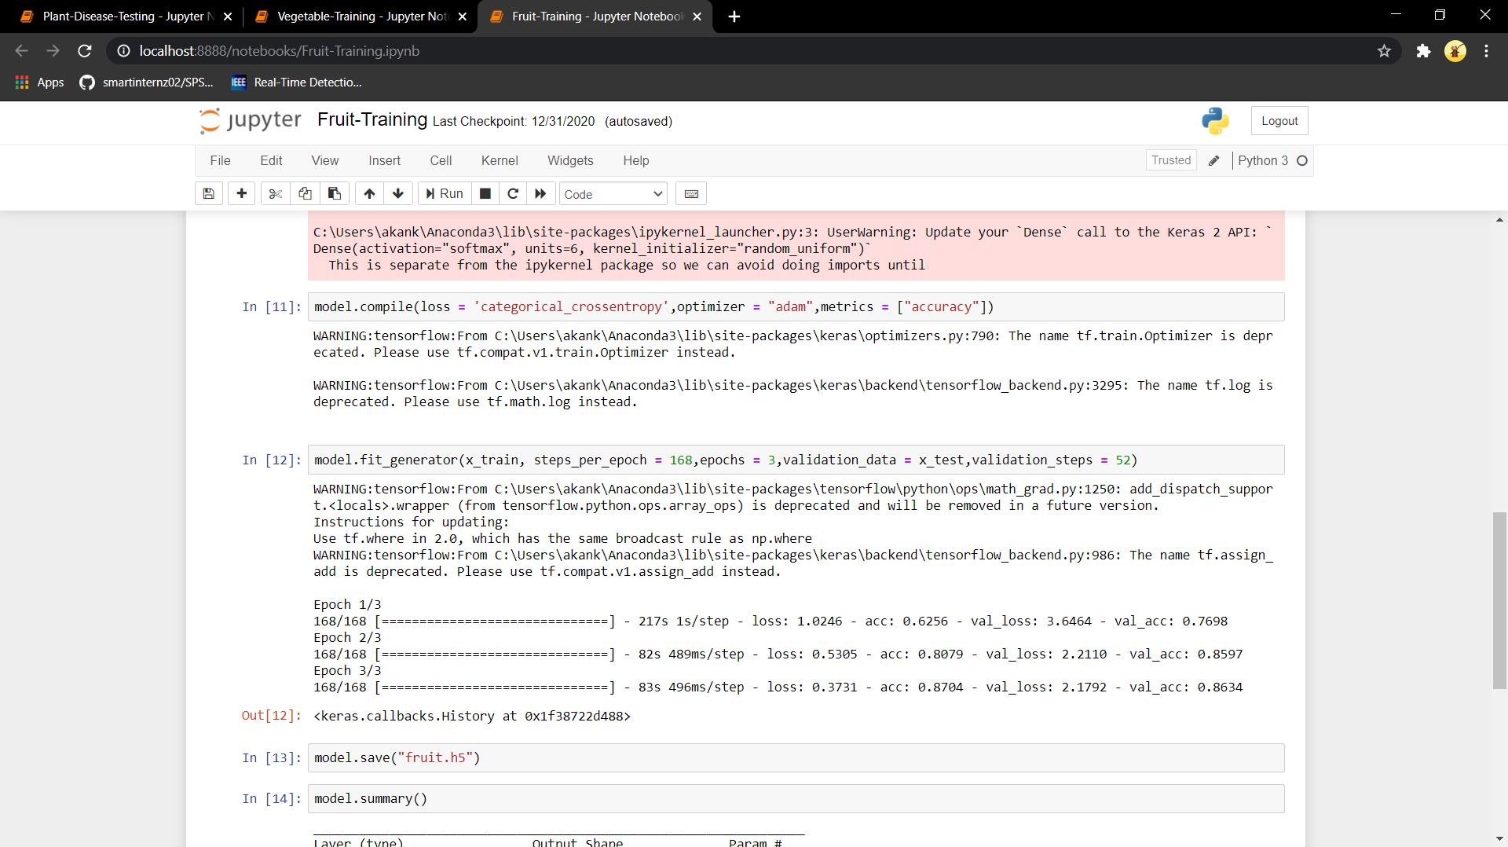

8
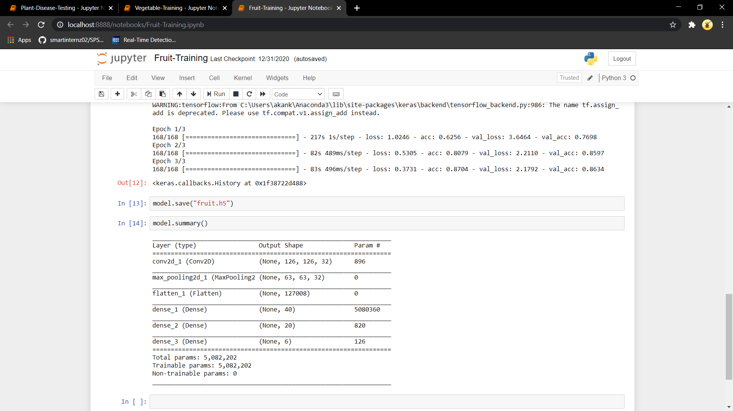

Vegetable-Training.ipynb

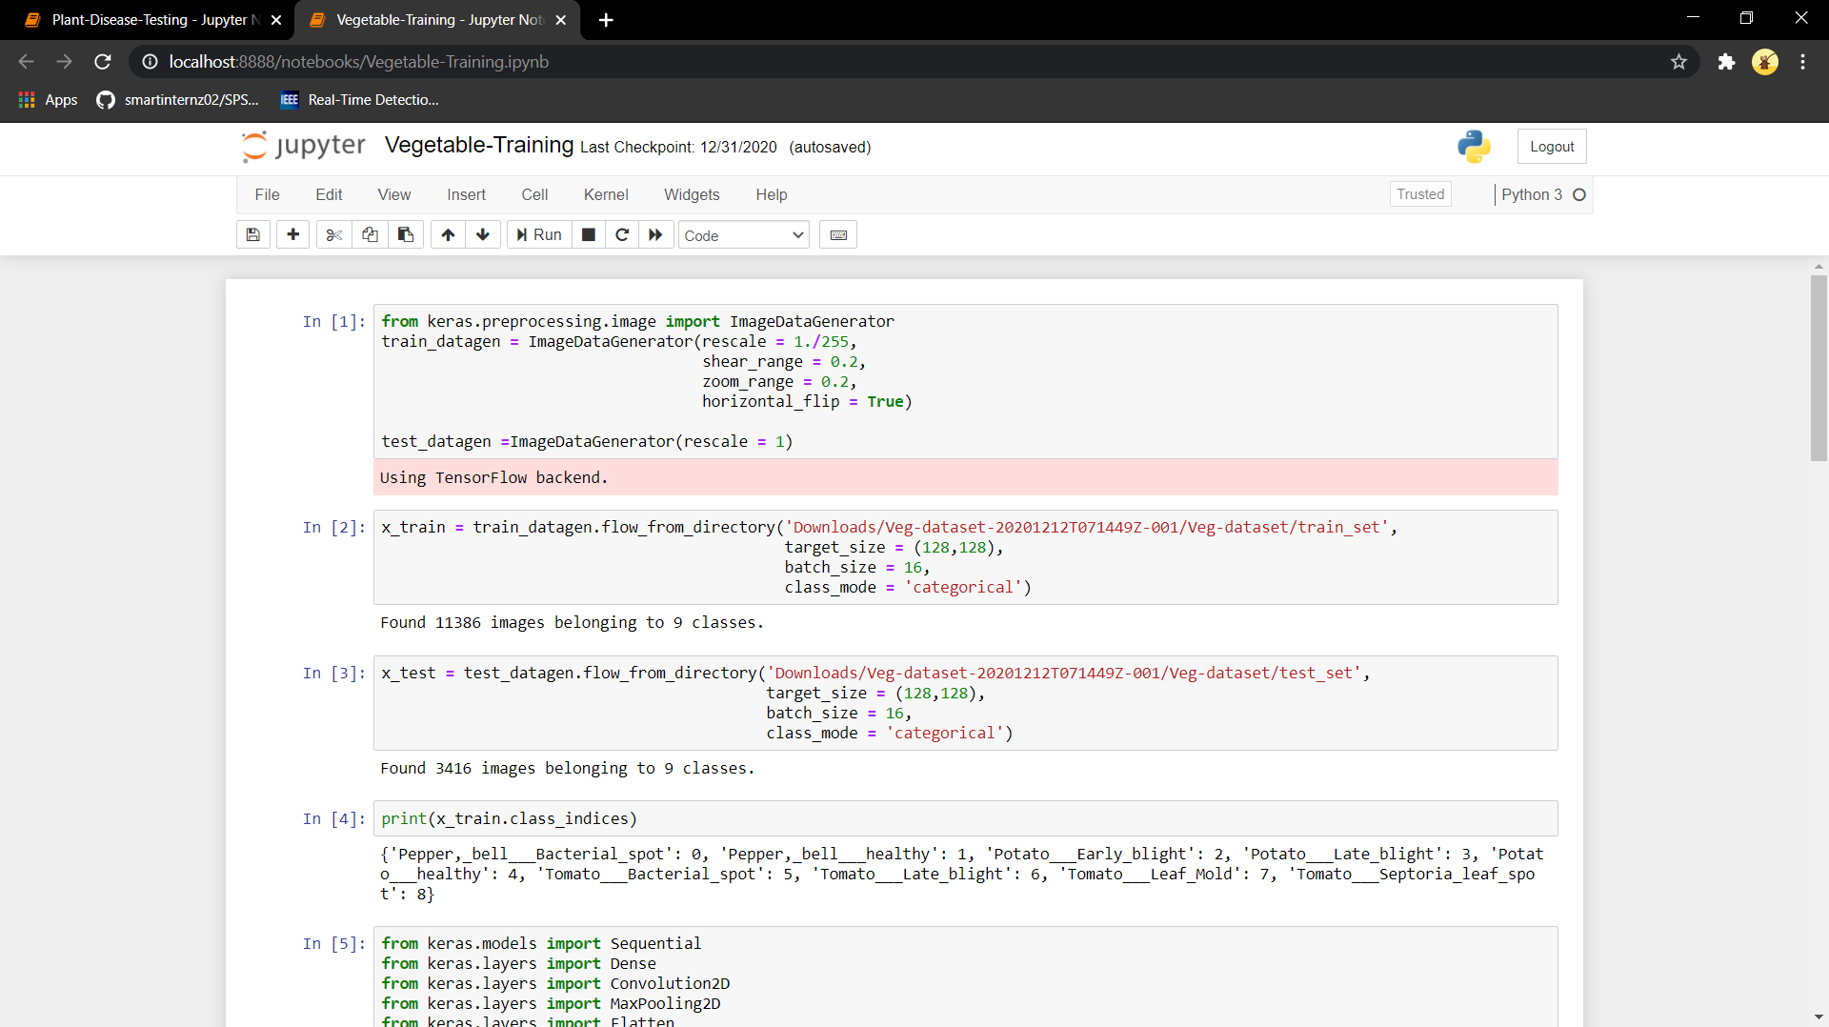

9
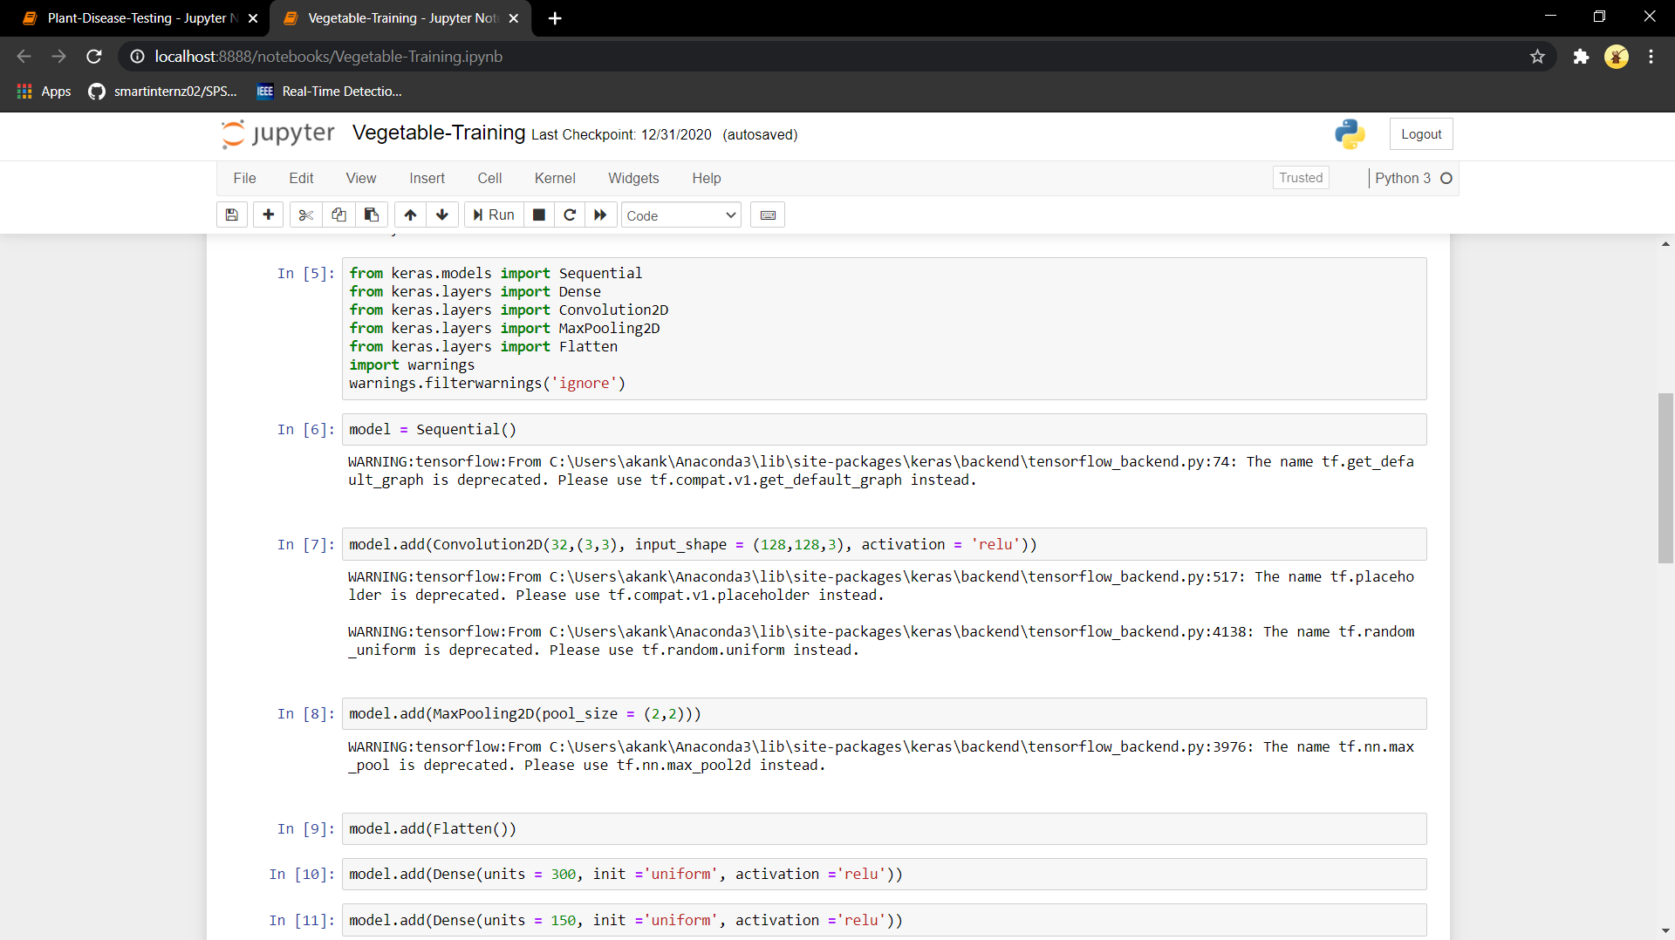

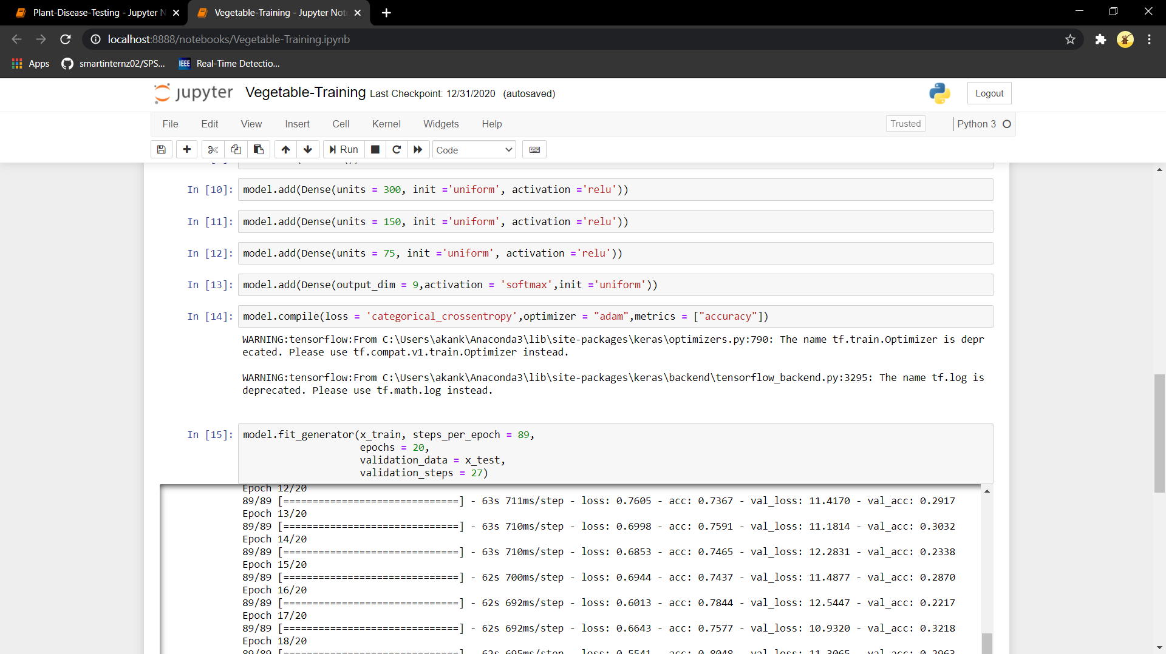

10
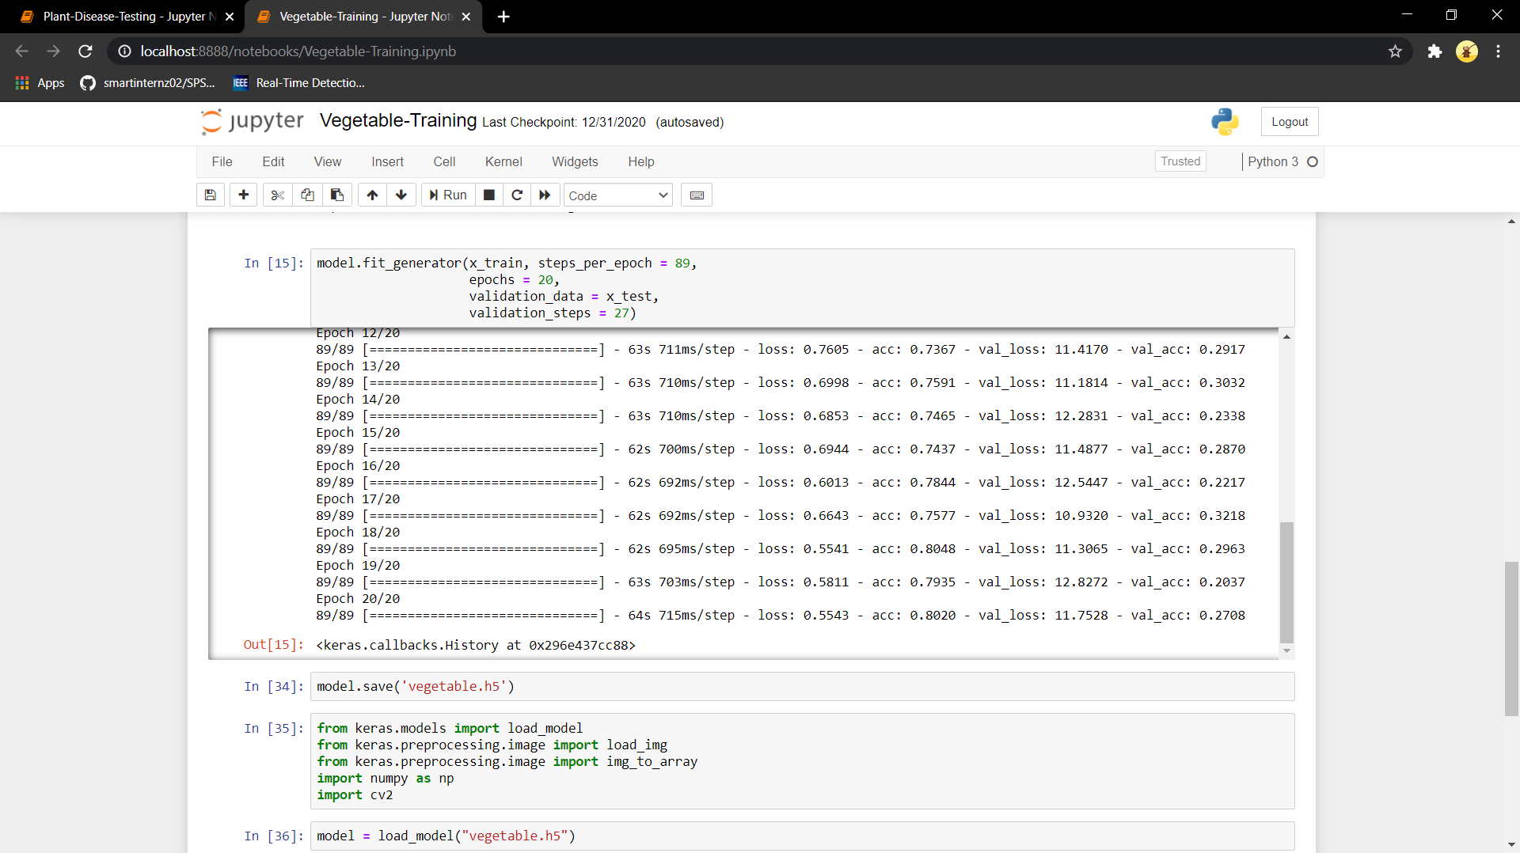

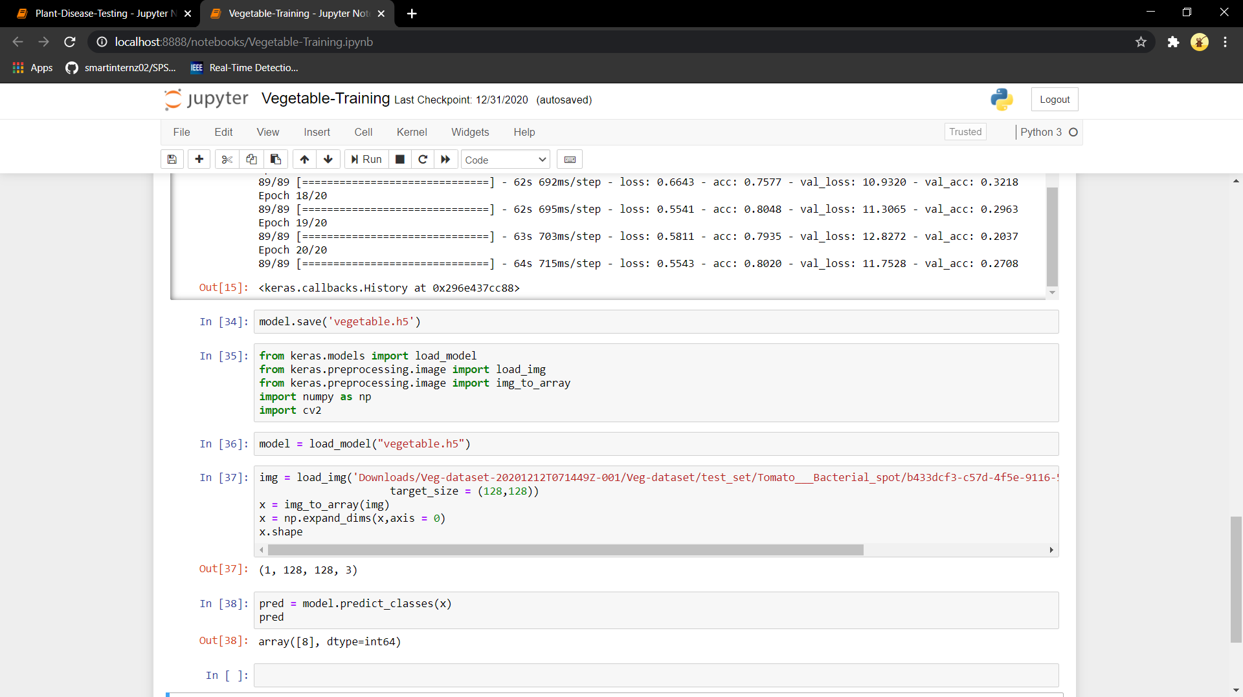

Plant-Disease-Testing.ipynb

11
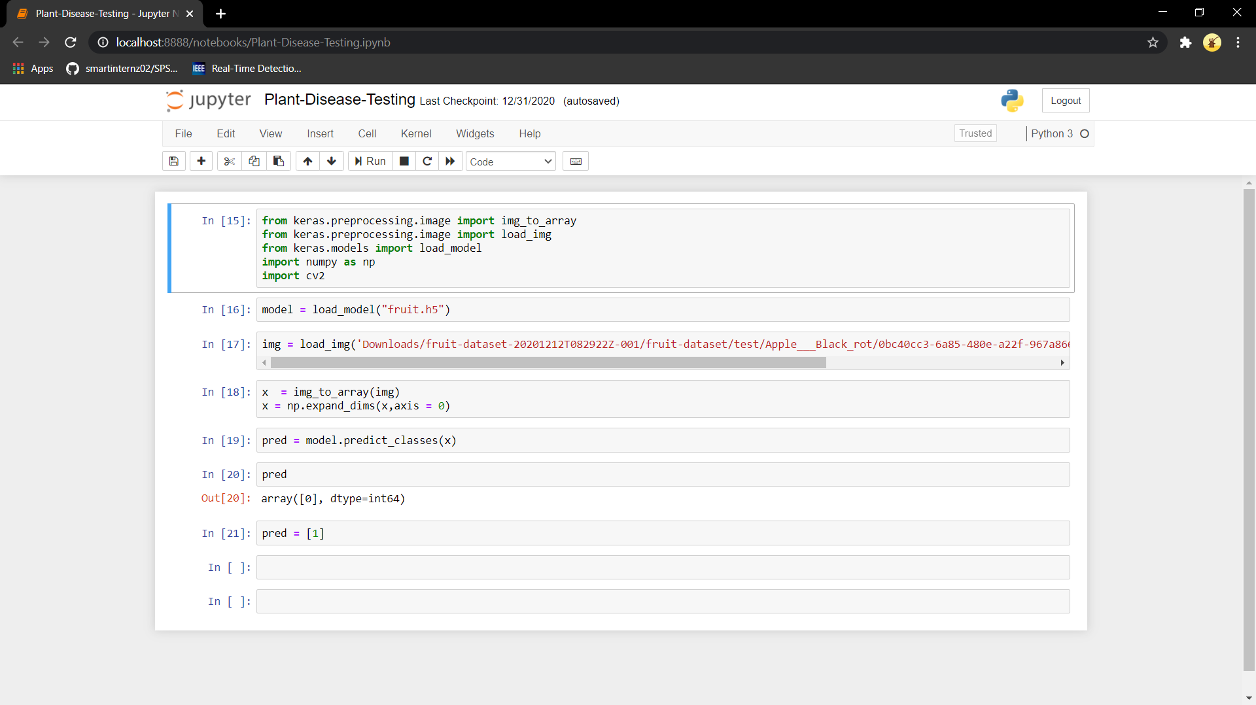

12

